273/1
GEOGRAPHY
Nov 2020
Time: 2 hours 30 minutes

KING’S COLLEGE – BUDDO
UGANDA CERTIFICATE OF EDUCATION
INTERNAL MOCK EXAMINATIONS 2020

INSTRUCTIONS TO CANDIDATES

This paper consists of parts I and II.
Part I and section A of part II are compulsory.
Answer only one question from section B of part II.
Answers to all questions must be written in the answer booklet provided.

PART I
OBJECTIVE TYPE QUESTIONS
Answer all the 30 questions.
1. Which of the following highlands in Tanzania was formed by block faulting?
A. Longonot C. Marsabit
B. Ulunguru D. Aberdere

2. Limestone rocks around Tanga have been chemically weathered to form
A. beaches C. coastal arches
B. coastal caves D. blow holes

3. The Uasin Gishu plateau in Kenya was mainly formed by the process of
A. single eruption of acidic lava C. fissure eruptions of basic lava
B. central vent eruption of lava D. alternate eruptions of lava and ash

4. The pattern of rainfall distribution on Zanzibar island is mainly influenced by
A. latitudinal location C. trade winds movements
B. the coastal alignment D. height above sea level

5. The major economic activity carried out on the flood plains of river Manafwa is
A. fish farming C. agro forestry
B. irrigation farming D. livestock rearing

6. The major land use type at altitudes of 2000-3000metres on Mt. Meru in Tanzania is
A. tourism C. forestry
B. settlement D. dairy farming

7. Which of the following areas in East Africa experiences a double maxima of rainfall?
A. Kasese C. Butiaba
B. Kisumu D. Mombasa

8. The type of climate which is experienced in the islands of Kalangala is
A. humid tropical C. modified equatorial
B. tropical maritime D. tropical continental

9. Dairy farming is well developed in the Kenya highlands of East Africa mainly because of
A. heavy rainfall C. reliable market
B. fertility of soil D. efficient transport

10. The major problem facing livestock rearing in the cattle corridor of Uganda is
A. seasonal rainfall C. loss of fertile soil
B. shortage of labour D. pests and diseases.

11. The tropical climate areas of East Africa mainly experience seasonal rainfall and
A. prolonged droughts C. high pressure belts
B. warm temperatures D. divergence of winds

12. Tea growing in south western Tanzania is mainly affected by the problem of
A. disease attacks C. limited markets
B. soil infertility D. shortage of labour

13. The mining activity which has caused extensive land degradation in East Africa is
A. limestone at Hima C. diamond at Mwadui
B. gold at Kakamega D. soda ash at Magadi

14. High population density in the highlands areas of East Africa is mainly influenced by
A. mining activities C. fertility of soils
B. reliable rainfall D. improved transport

15. The major cash crop grown in Bundibugyo district in western Uganda is
A. coffee C. palm oil
B. cotton D. pyrethrum

16. The mineral deposits in Lake Magadi have been formed by the process of
A. deposition of brine around hot springs C. precipitation caused by hot temperatures
B. chemical weathering of volcanic plugs D. sedimentation in an inland drainage basin

17. The process by which granites are weathered into feldspar and quartz is called
A. hydrolysis C. carbonation
B. hydration D. oxidation

18. Wetland reclamation in southern Uganda has mainly led to the problem of
A. flooding of river valleys C. outbreak of water borne diseases
B. lowering of water tables D. destruction of wildlife habitats

19. The major problem caused by dense settlements on the slopes of Mt Ruwenzori is
A. decreased precipitation C. flooding of rivers
B. destruction of vegetation D. wide spread of diseases

20. Which of the following is an example of a heavy industry in East Africa?
A. food processing C. iron and steel
B. pharmaceuticals D. vehicle assembly.

21. Agricultural development in the rift valley areas of East Africa is mainly limited by
A. soil erosion C. infertile soils
B. unreliable rainfall D. pests and diseases.

22. Soft wood trees are being grown in East Africa mainly because they
A. provide many products B. have short maturity periods
B. are resistant to droughts D. help conserve marginal lands

23. The method commonly used to preserve protopterus fish in East Africa is
A. smoking B. salting
B. canning D. sun drying

24. Which of the following industries in Kenya largely produces for the export market?
A. petroleum refining B. iron and steel works
B. beverage processing D. cement manufacture

25. The growth of corals along the East African coast is mainly favoured by
A. murky waters B. saline waters
B. muddy waters D. shallow waters

26. The method used for commercial production of limestone in western Uganda is
A. placer mining B. drilling
B. dredging D. open-cast

27. Commercial fishing on Lake Albert is mainly hindered by
A. steep escarpments B. market shortage
B. limited fish species D. poor fishing gear

28. Which of the following national parks are found in Kenya?
A. Tsavo and Marsabit B. Serengeti and Ruaha
B. Biharamulo and Meru D. Amboseli and Rungwa.

29. Which of the following rocks is a raw material for making building tiles?
A. Quartzite B. Marble
B. Graphite D. Gneiss

30. Fish farming in East Africa is mainly carried out in areas which have
A. gentle slopes C. broad valleys
B. well drained soils D. permanent rivers

PART II
MAPWORK, PHOTOGRAPH INTERPRETATION, FIELD WORK AND EAST AFRICA

Answer four questions from part II, including questions 1, 2 and 3 which are compulsory.

SECTION A

- COMPULSORY QUESTION: MAPWORK.
Answer all parts of this question.

Study the 1:50,000 (UGANDA): NYARWEYO map extract, Series Y732, part of sheet 87/4, Edition 3 – U.S.D and answer the questions that follow:
(a) Identify the
(i) man-made feature found at grid reference 104364
(ii) physical feature found at grid reference 164262. (2 marks)

(b) (i) Measure and state in Km² the area covered by Butemba sub county. (2 marks)

(ii) State with evidence the direction of flow of river Kadiki (Kafu). (2 marks)

(c) Draw a sketch map of the area shown on the map extract and on it mark and name
(i) ridges
(ii) swamps
(iii) forest reserve
(iv) transport routes. (6 marks)

(d) (i) Describe the relationship between relief and land use types on the map extract.
(4 marks)

(ii) Explain the problems faced by the people living in the area shown in the map extract.
(4 marks)

- COMPULSORY QUESTION: PHOTOGRAPHIC INTERPRETATION.
Study the photograph provided below and answer the questions that follow:

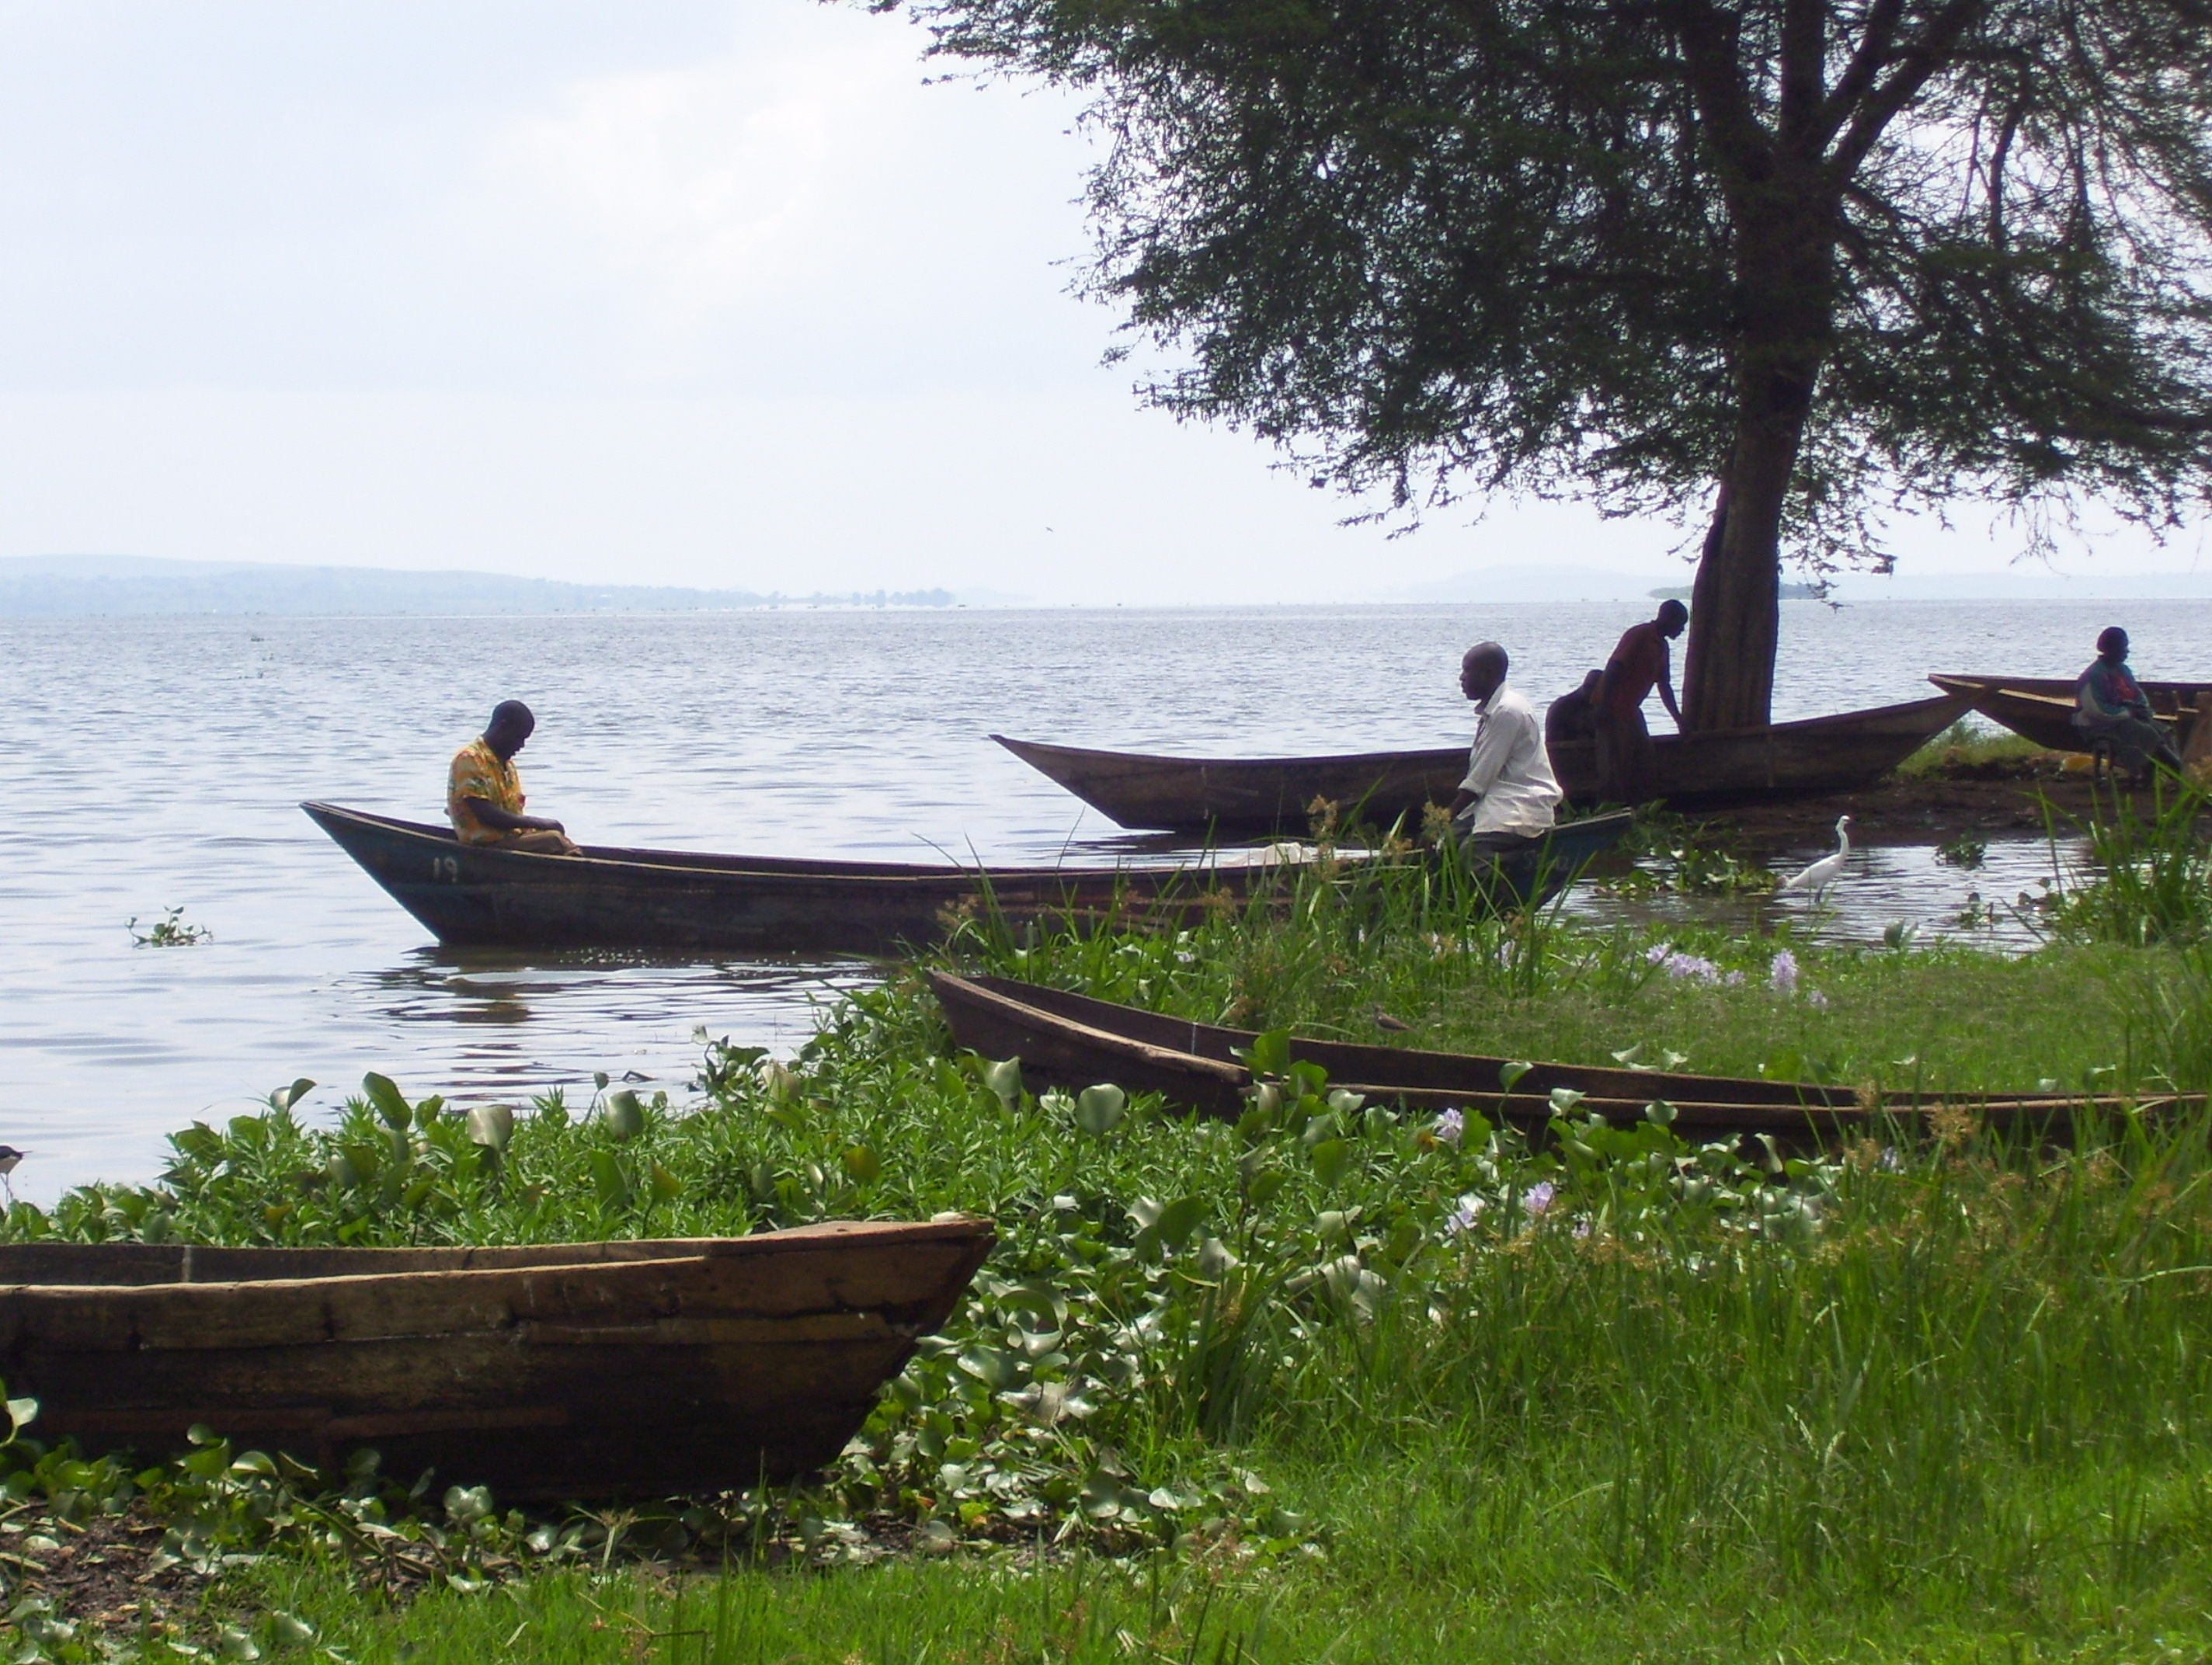

(a) (i) Identify with evidence the type of photograph shown above. (2 marks)

(ii) State the economic activity carried out in the area shown in the photograph. (1 mark)

(b) Describe the factors which have favoured the economic activity identified in (a)(ii) above.
(6 marks)

(c) Explain the problems created by this activity to the surrounding areas in the photograph.
(5 marks)

(d) Suggest any one area in East Africa where the photograph could have been taken from.
(1 marks)

3. COMPULSORY QUESTION: FIELDWORK
For any one fieldwork study you have carried out on a livestock farm or landing site:
(a) State the:
(i) topic of your study and (2 marks)
(ii) objectives of your field work study. (2 marks)
(b) Draw a cross section of the area of your field work study and on it mark and name the:
(i) physical features
(ii) land use types
(5 marks)
(c) Explain the findings of your field work during your study of the area stated above.
(4 marks)
(d) Explain the difficulties you faced in the field while carrying out this field work study.
(2 marks)

SECTION B: EAST AFRICA (20 MARKS)

Answer only one question from this section.

4. (a) Draw a sketch map of East Africa and on it, mark and name:

(i) Ports: Mombasa and Dar es Salaam
(ii) Highlands: Kenya and Kilimanjaro
(iii) Rivers: Tana and Rufiji. (7 marks)

(b) Describe the conditions which have favoured the formation of coral reefs in East Africa. (6 marks)

(c) Explain the value of coral reefs to the economic development of East Africa.
(4 marks)

(d) Outline the problems caused by coral reefs to the people living along the coast of East
Africa. (3 marks)

5. Study the table below showing Kenya’s export crops (2002-2003) in metric tonnes and answer the questions that follow.

Export Crop | 2002  (Metric Tonnes) | 2003  (Metric Tonnes)
Coffee  Tea  Sisal  Tobacco  Sugar cane  Oil palm | 17,000  88,000  9,ooo  108,000  37,ooo  2,000 | 63,000  294,000  24,000  50,000  39,000  33,000
Adapted: Africa Development Indicators, 2007 (p.21) World Development Indicators 2008 Pp 40-41. The World Bank Washington D.C.

- Calculate the percentage change in Kenya’s export of food crops in 2002-2003.
(5 marks)

(b) Draw a bar graph to represent the amount of Kenya’s export of food crops in 2003.
(5 marks)

(c) Describe the conditions which have influenced the trend of Kenya’s export crops as shown in the table above. (6 marks)

(d) Explain the steps being taken to promote the export of agricultural crops in Kenya.
(4 marks)

6.(a) Draw a sketch map of East Africa and on it mark and label the following:

(i) Rivers: Tana and Rufigi
(ii) Irrigation Schemes: Kilombero and Mwea-Tebere
(iii) Towns: Nairobi and Dar es Salaam. (7 marks)

(b) Describe the factors which have favoured the location of Kilombero irrigation scheme in Tanzania. (6 marks)

(c) Explain the benefits of irrigation farming to the economic development of Tanzania.
(4 marks)

(d) Outline the problems caused by irrigation farming on the environment in East Africa.
(3 marks)

7. Study the table below showing arrival of tourists into East Africa (1995-2006) and answer the questions that follow:

Tourist Arrival into East Africa 1995 – 2006.
Country | 1995 | 2006
Tanzania  Kenya  Uganda | 285,000  896,000  160,000 | 622,000  1,536,000  539,000
Total | 1,341,000 | 2,697,000

Adapted: World Development Indicators (2008). The World Bank, Washington D.C. Pp. 377-378.
(a)(i) Calculate the percentage change in the number of tourists’ arrival for each country in East
Africa between 1995 and 2006. (6 marks)

(ii) Identify the country in East Africa with the lowest growth rate in the arrival of tourists
between 2005 and 2006. (1 mark)

(b) Draw a pie-chart to show the number of tourists’ arrival into East Africa in the year 2006.
- marks)

(c) Explain the factors which have led to the trend of tourists’ arrival into East Africa as shown in
(a)(i) above. (5 marks)

(d) Outline the problems caused by the tourist industry on the environment in East Africa. (3 marks)

_ END_

